Log File

- Unzip Midi file.

- Load Midi file unto Google Colab File area.

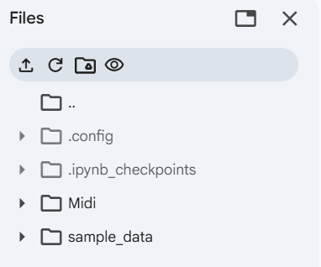

Ensure the Midi file is placed in Google Colab as shown here

- Run .ipynb file in Google Colab.

- Download generated_music.midi file.

- Listen to file with Windows audio player.

- Perform steps 3 – 5 again. (Generated midi file should sound different.)

